**Project Aim**

**Automating the Star Health Application Using Selenium**

**Selenium**

Selenium is a popular open-source testing tool used for web application testing. It enables testers to write automated tests in various programming languages to test the functionality of web applications. Selenium tests can be run on many different browsers and operating systems.

**JUnit**

JUnit can help you keep your code organized and easy to read. JUnit can help you detect and fix errors in your code. JUnit can help you improve the quality of your software. JUnit can help you work more efficiently and improve your testing process.

**TestNG**

The main aim of the TestNG framework is to simplify and improve the testing process for Java applications. It provides features for testing, such as parallel execution, grouping of test methods, test prioritization, data parameterization, and reporting. TestNG is widely used for unit, functional, and integration testing in Java applications, and it offers more flexibility and functionality compared to the older JUnit framework.

**Cucumber**

Cucumber Framework in Selenium is an open-source testing framework that supports Behavior Driven Development for automation testing of web applications. The tests are first written in a simple scenario form that describes the expected behavior of the system from the user's perspective.

**Jenkins**

The primary aim of a Jenkins server is to automate various tasks related to building, testing, and deploying software. Jenkins is an open-source automation server that helps streamline the software development process by facilitating continuous integration and continuous delivery (CI/CD).

**I used following Tools:**

● Eclipse

● Java

● Git

● Jenkins

● Cucumber-Java maven dependency

● Cucumber-JUnit maven dependency

● Selenium maven dependency

● TestNG maven dependency

**Test Scenario: 1 [Cucumber + JUnit]:**

**Steps:**

**Step-1:**

First I created a maven project

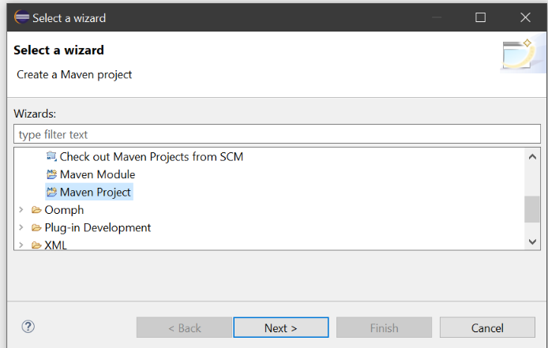

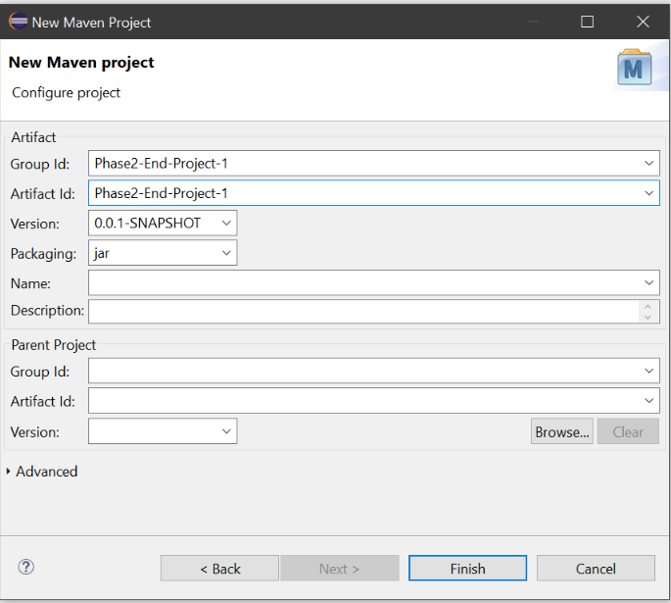

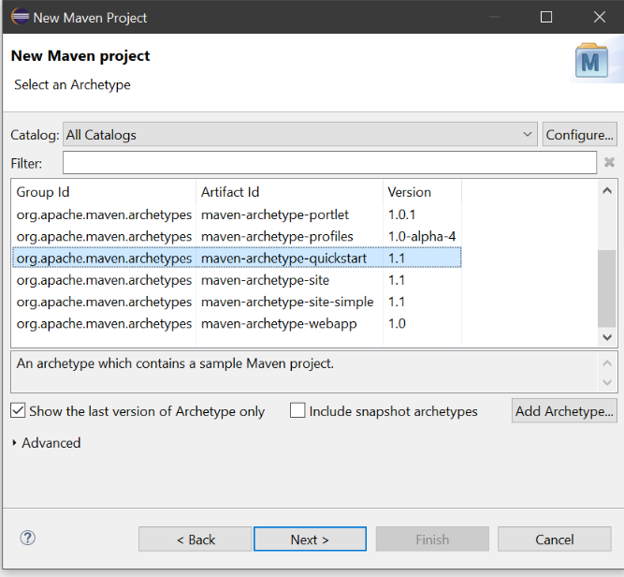

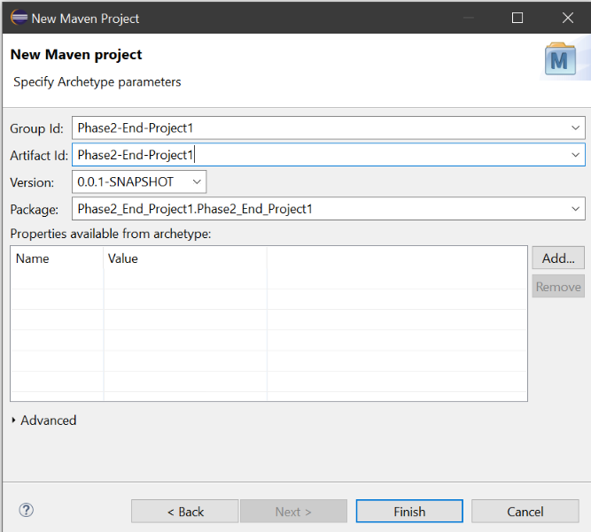

**Step-2:**

Then I add dependencies in pom.xml file

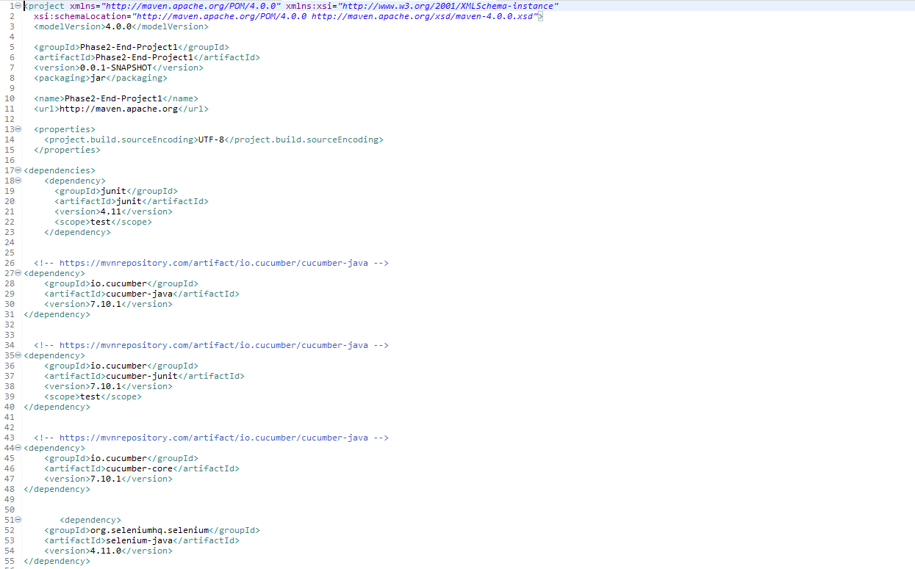

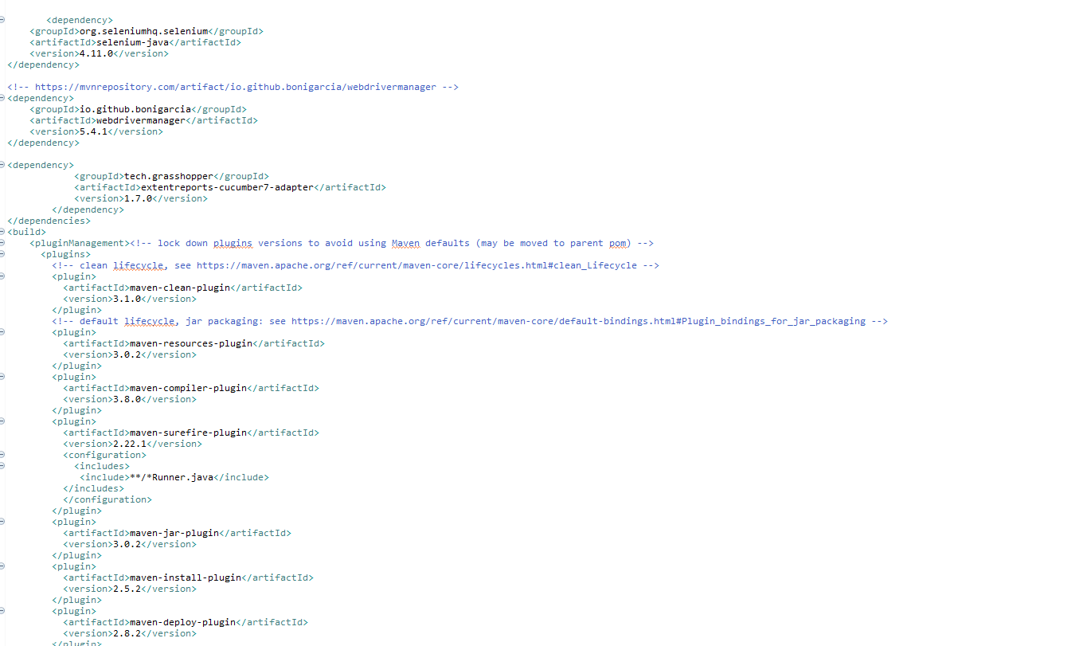

**Step-3:**

Then I converted the project to cucumber project

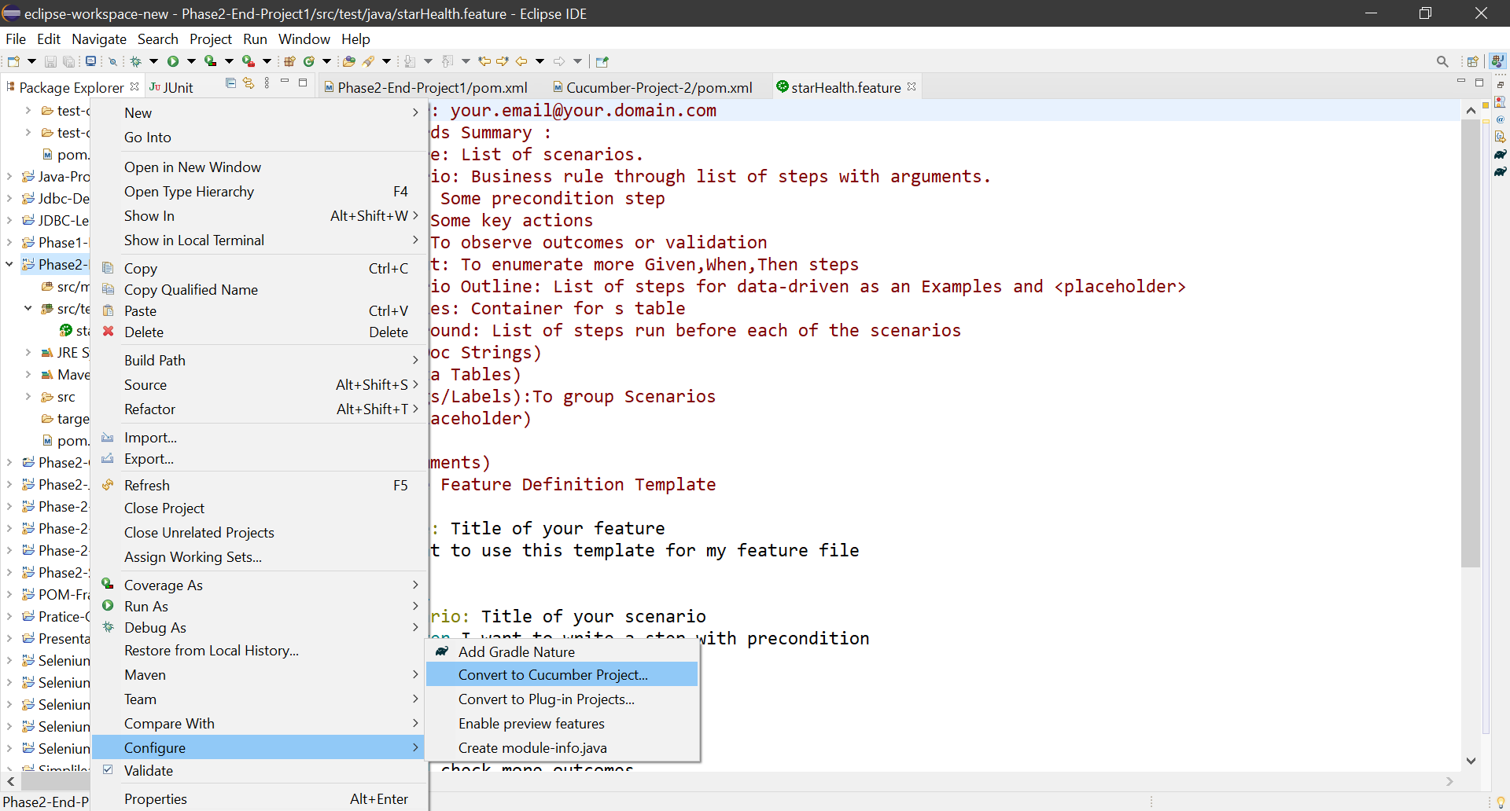

**Step-4:**

Then I create packages

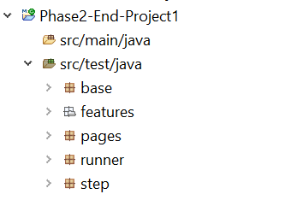

**Step-5:**

Then I create feature file and classes

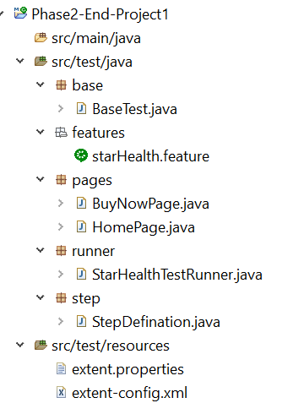

**Step-6:**

Then I run it

**Step-7:**

Then I push this project in my github repository

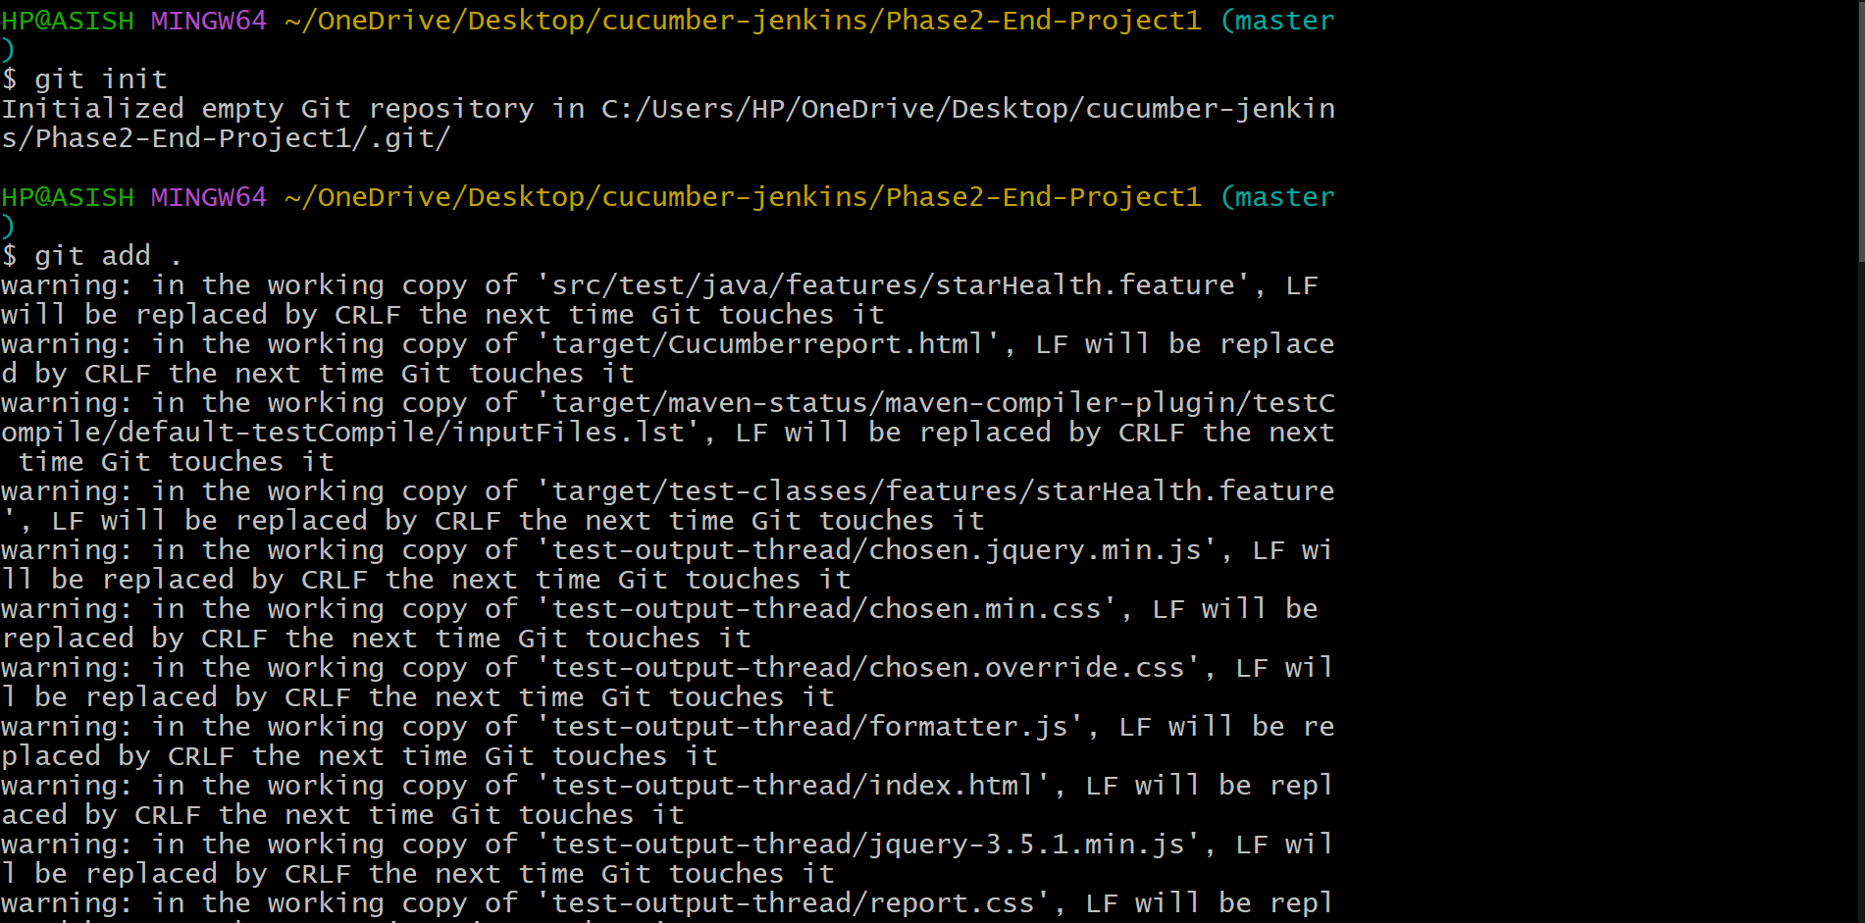

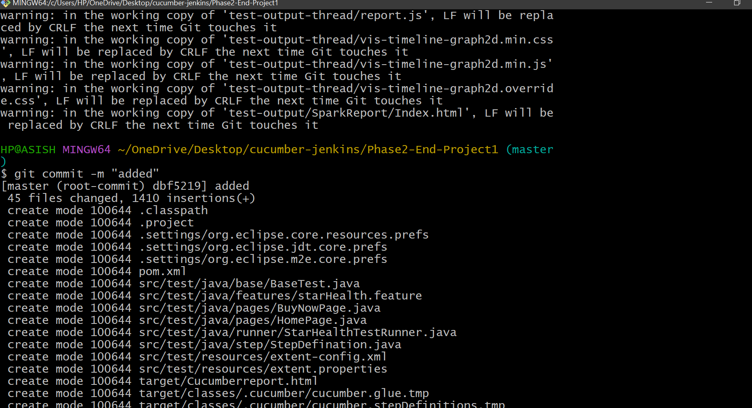

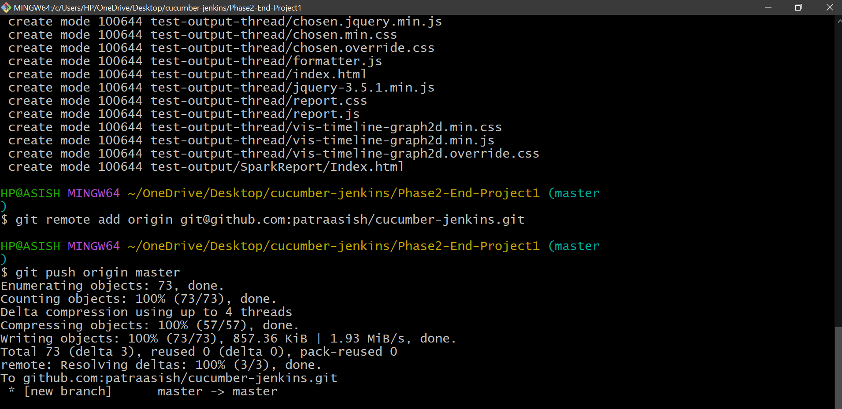

**Step-8:**

Then I create a freestyle project in Jenkins

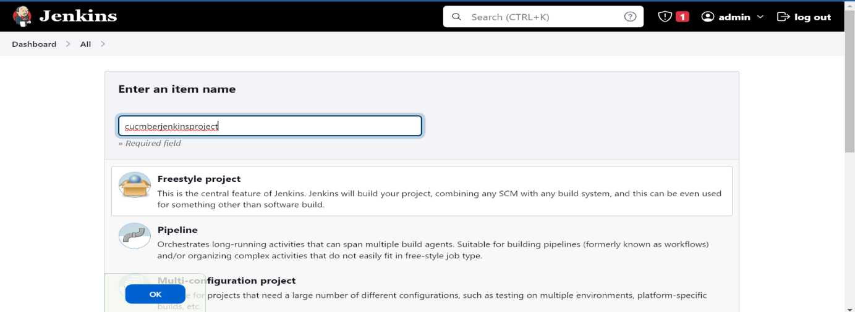

**Step-9:**

Then I configure it

**Step-10:**

Then I buid it

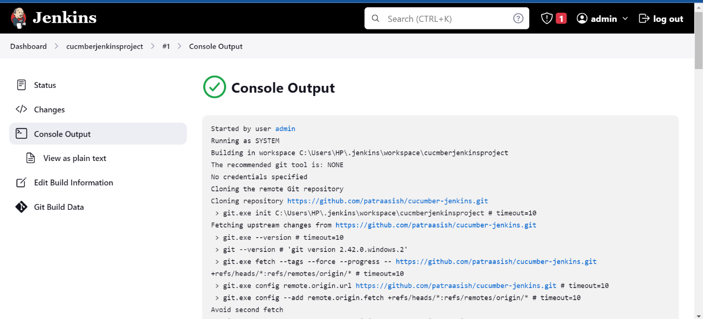

**Test Scenario: 2 [TestNG + Selenium]**

**Step-1:**

First I created a maven project

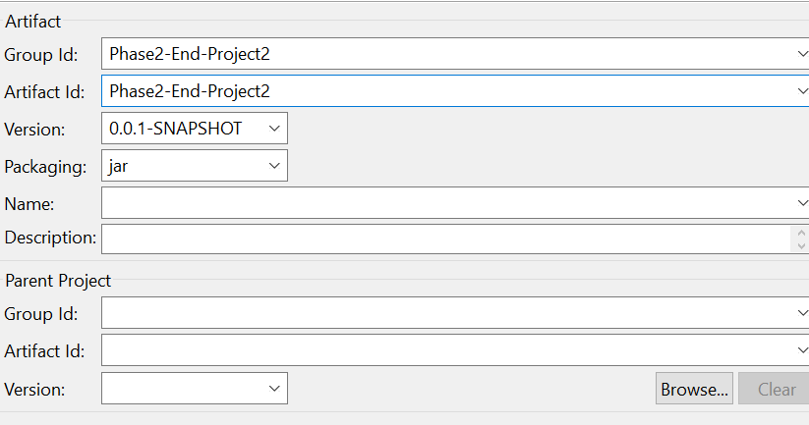

**Step-2:**

Then I added dependencies in pom.xml file

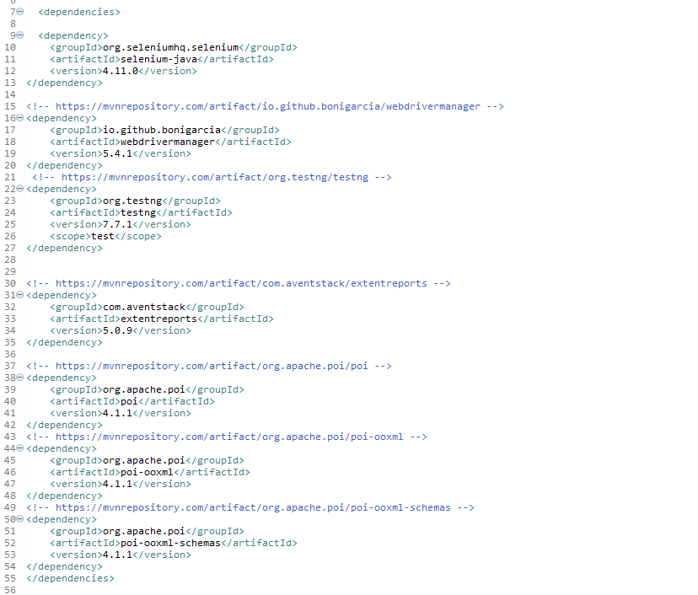

**Step-3:**

Then I create packages

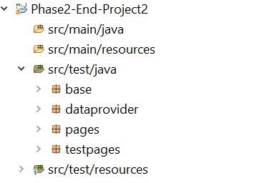

**Step-4:**

Then I create classes and xml file

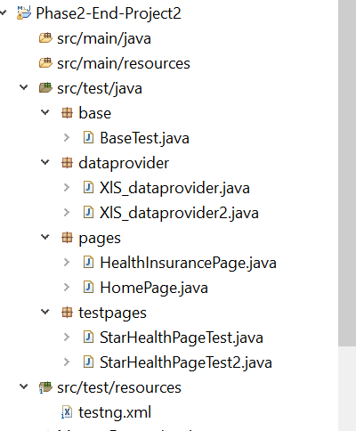

**Step-5:**

Then I run it

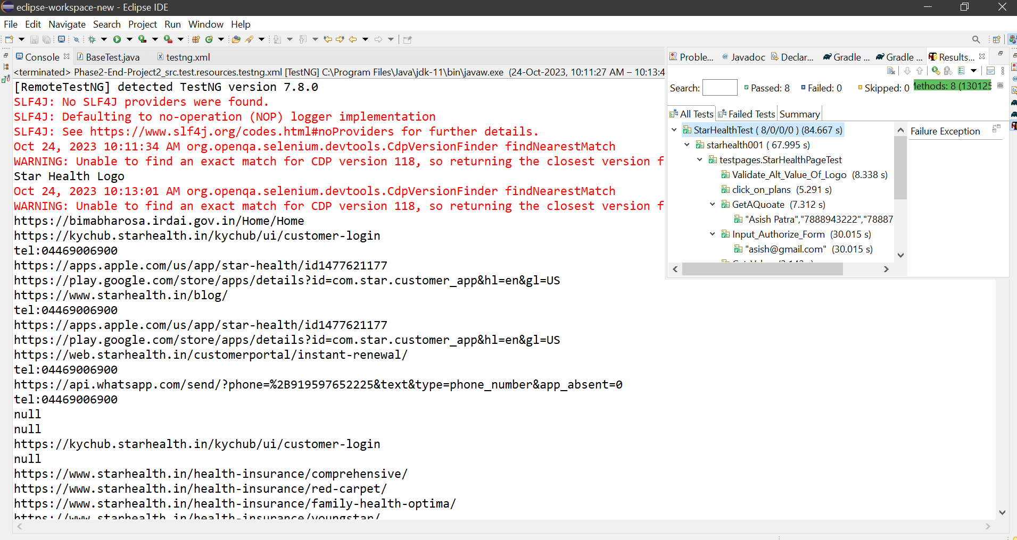

**Step-6:**

Then I push the project in my github repository

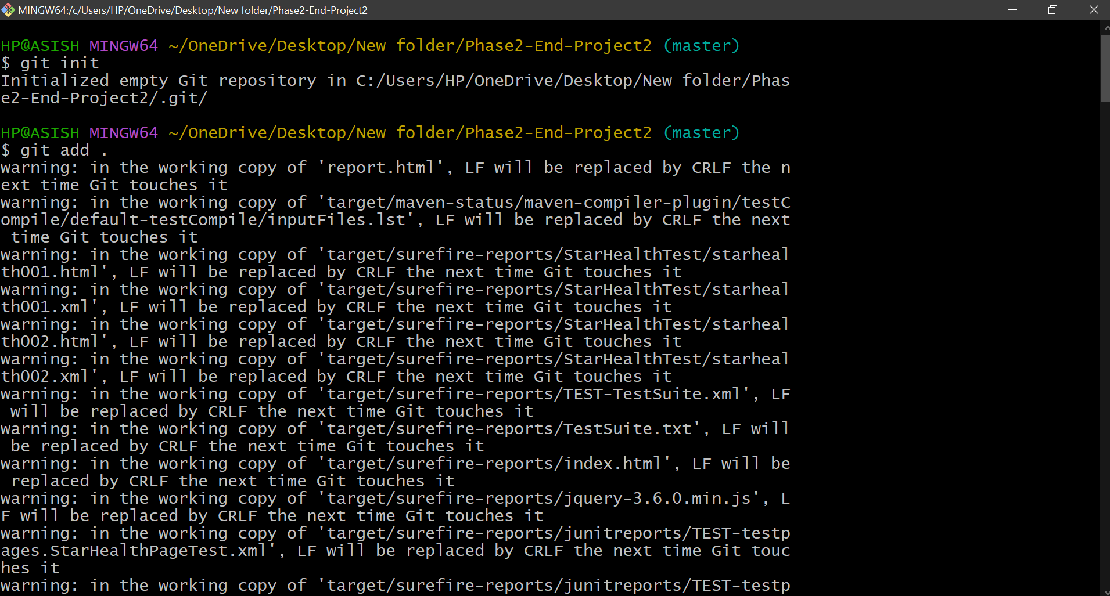

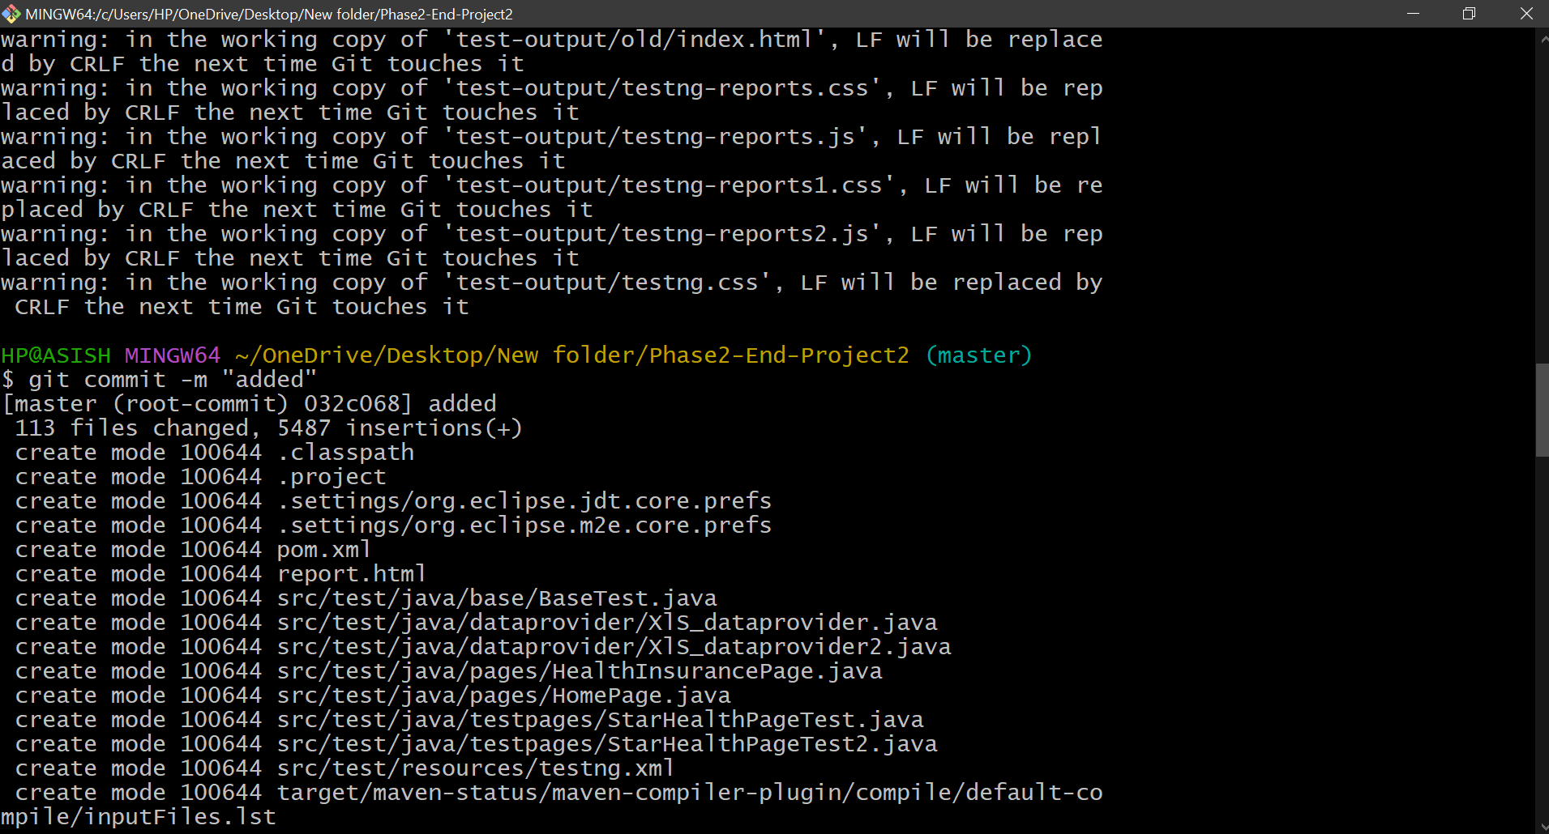

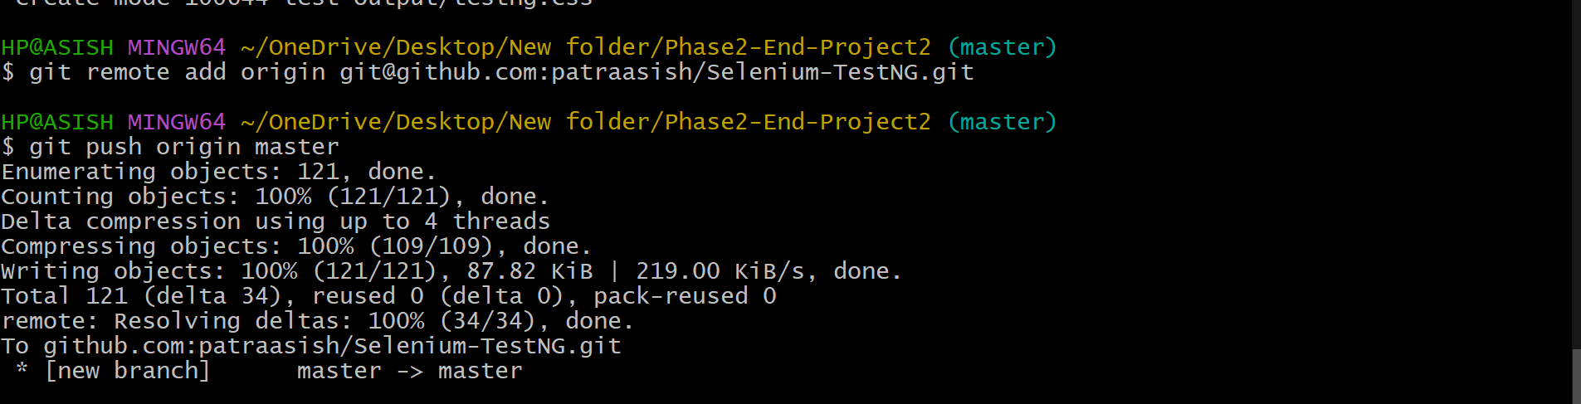

**Step-7:**

Then I create a freestyle project in Jenkins and configure it.

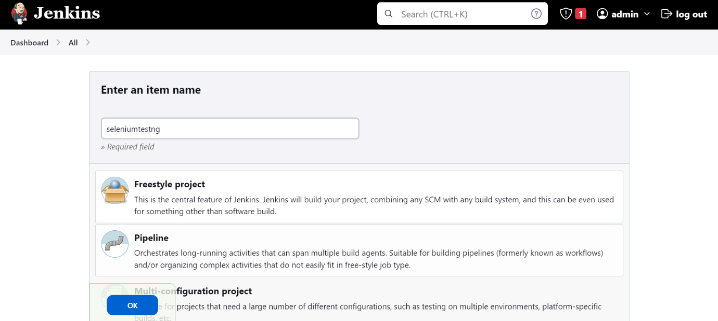

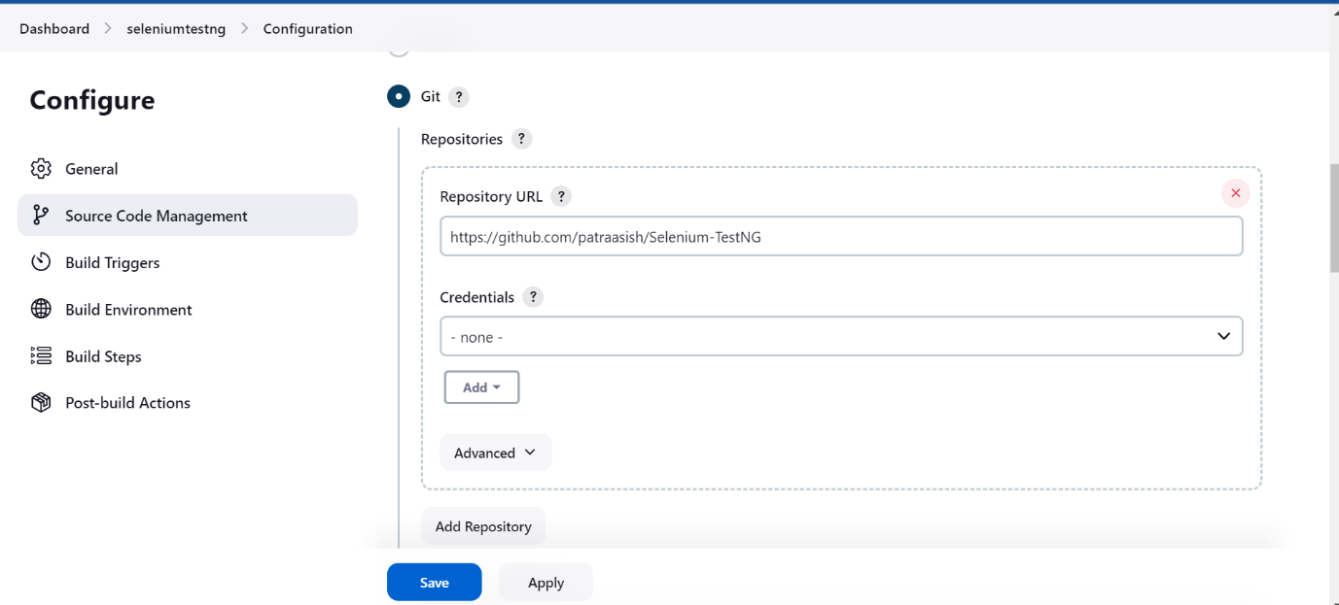

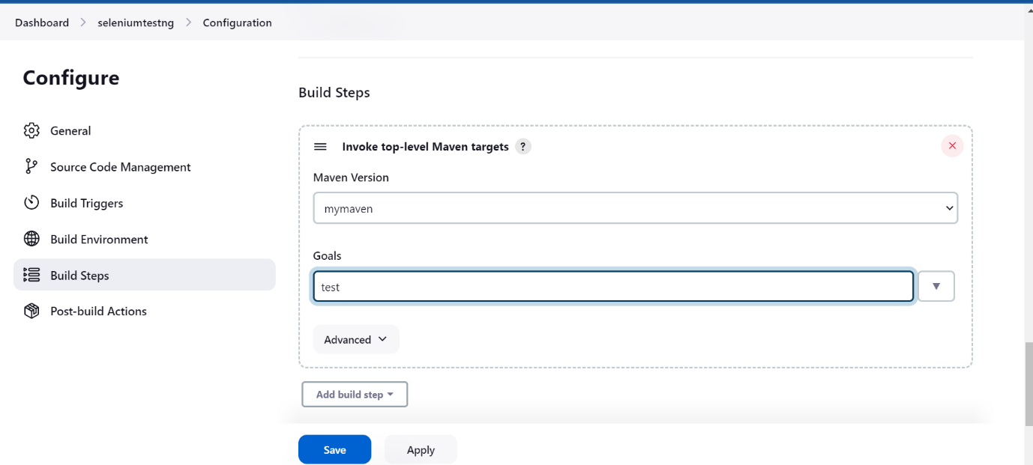

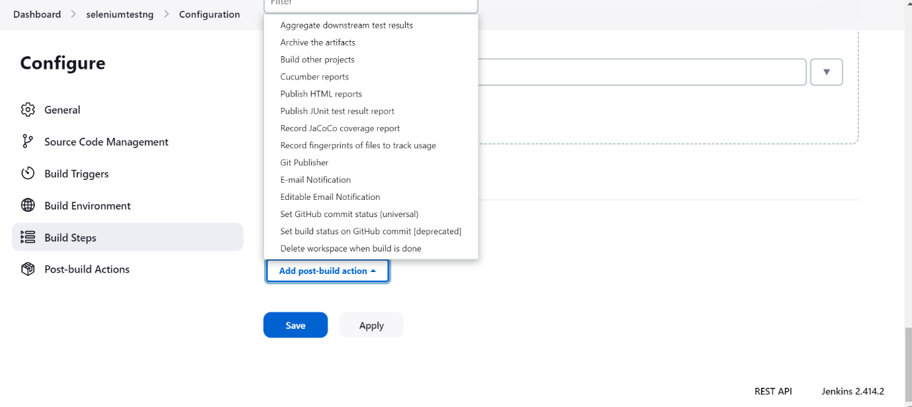

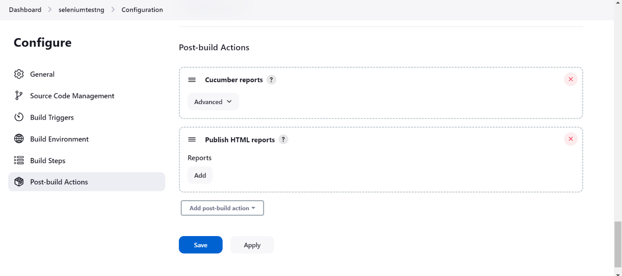

**Step-8:**

Then I build it

